Practical Lab Experiment 1
- Demonstration on basics of Numpy.

A. NumPy Array Creation.
Code:
import numpy as np
#Array Using np.array()
arr1 = np.array([1,2,3,4,5])
print("1D Array : \n", arr1)
arr2 = np.array([[1,2,3], [4,5,6]])
print("2D Array : \n", arr2)
arr3 = np.array([[[1,2,3], [4,5,6], [7,8,9]]])
print("3D Array : \n", arr3)
#Array using np.zeros()
z = np.zeros((2,3))
print("Array using zeros() function : \n", z)
#Array using np.ones()
o = np.ones((3,2))
print("Array using ones() function : \n", o)
#Array using np.arrange()
a = np.arange(0, 10, 2)
print("Array using arange() function : \n", a)
#Array using np.linspace()
l = np.linspace(0, 1, 5)
print("Array using linspace() function : \n", l)
#Array using np.eye()
i = np.eye(3)
print("Array using eye() function : \n", i)

Output:
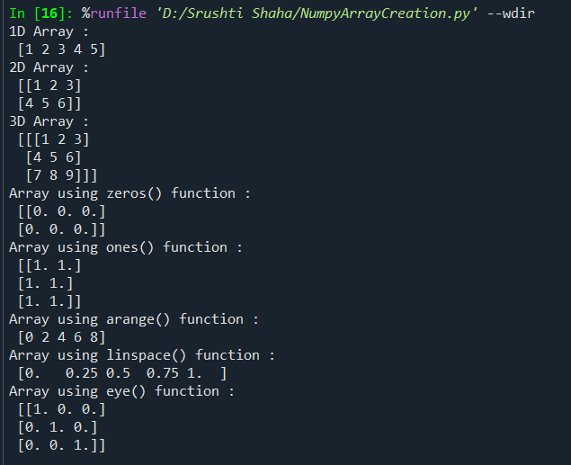

B. Array Attributes.
Code:
import numpy as np
#Array
arr = np.array([[1,2,3], [4,5,6]])
print("Array -> \n", arr)
#ndim
print("Number of dimensions -> ",arr.ndim)
#shape
print("Shape of array -> ",arr.shape)
#size
print("Total number of elements -> ",arr.size)
#dtype
print("Data type of elements -> ",arr.dtype)
#itemsize
print("Size of each element -> ",arr.itemsize)
#nbytes
print("Total memory used by array -> ",arr.nbytes)
Output:
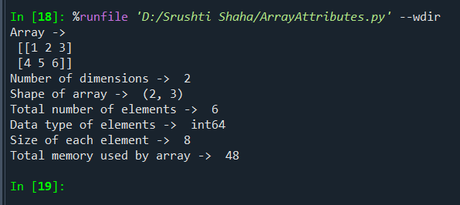

C. Array Indexing and Slicing.
Code:
import numpy as np
#1D Array
arr1 = np.array([10,20,30,40,50])
#2D Array
arr2 = np.array([[1,2,3], [4,5,6]])
#Accessing Element
print("1D Array -> \n", arr1)
print("2D Array -> \n", arr2)
print("Accessing array element -> ")
print(arr1[0])
print(arr1[-1])
print(arr2[0,0])
print(arr2[1,0])
#Slicing
print("Slicing -> ")
print(arr1[1:2])
print(arr1[:2])
print(arr1[1:])
print(arr1[::2])
print(arr2[0:1, 1:3])
print(arr2[:, 0])
print(arr2[1, :])
#Reversing
rev = arr1[::-1]
print(rev)
print(arr2[::-1])
print(arr2[:, ::-1])
print(arr2[::-1, ::-1])
#Specific row and column
row = arr2[[0,1], :]
print(row)
Output:
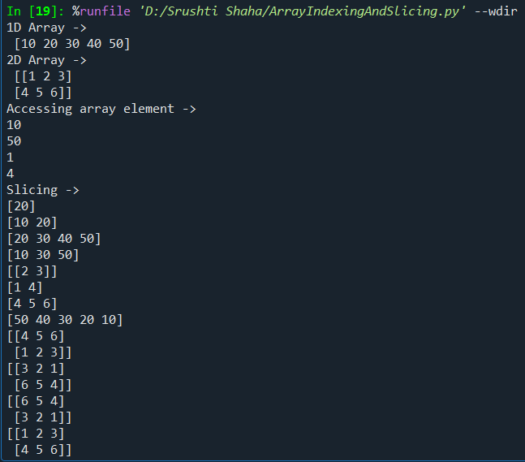
D. Array Reshaping.
Code:
#ArrayReshaping
import numpy as np
arr = np.array([1,2,3,4,5,6])
print("Array -> \n", arr)
reshaped2d = arr.reshape(2,3)
print("1D to 2D -> \n",reshaped2d)
reshaped3d = arr.reshape(2,3,1)
print("1D to 3D -> \n",reshaped3d)
#Flatten multidimentional array using - revel() & flatten()
flat1 = reshaped2d.ravel()
print("Ravel array -> \n",flat1)
flat2 = reshaped2d.flatten()
print("Flatten array -> \n",flat2)
auto = arr.reshape(3, -1)
print("Automatic dimension -> \n",auto)
Output:
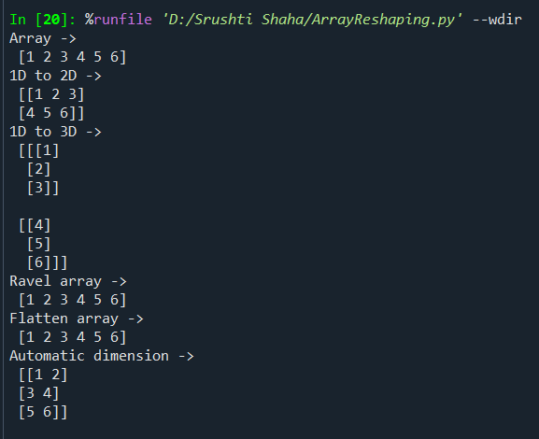
E. Mathematical Operations.
Code:
import numpy as np
a = np.array([10,20,30,40,50])
b = np.array([1,2,3,4,6])
#Arithmetic Operations
print("Addition -> ", a+b)
print("Subtraction -> ", a-b)
print("Multiplication -> ", a*b)
print("Division -> ", a/b)
print("Modulus -> ", a%b)
#Universal Operations
print("Square root -> \n",np.sqrt(a))
print("Exponential -> \n",np.exp(b))
print("Logarithm -> \n",np.log(a))
print("Power -> \n",np.power(b,2))

Output:
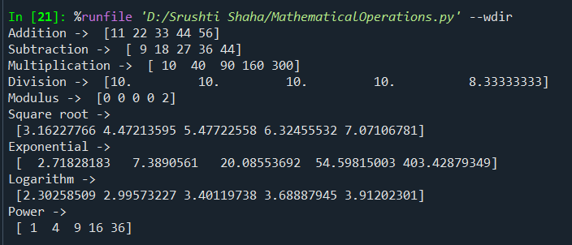

F. Aggregate Functions.
Code:
import numpy as np
arr = np.array([10,20,30,40,50])
print("Array -> ", arr)
print("Minimum -> ",np.min(arr))
print("Maximun -> ",np.max(arr))
print("Mean -> ",np.mean(arr))
print("Median -> ",np.median(arr))
print("Standard Deviation -> ",np.std(arr))
print("Sum -> ",np.sum(arr))
print("Index of min -> ",np.argmin(arr))
print("Index of max -> ",np.argmax(arr))

Output:
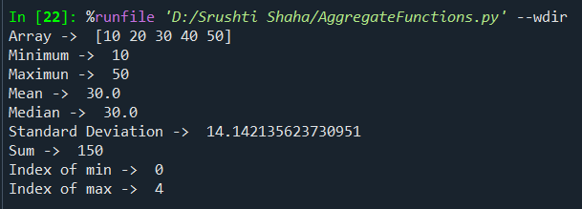

Practical Lab Experiment 2
2. Write a NumPy program to split the element of a array with spaces.

Code:
import numpy as np
arr = np.array(['Welcome To Python Programming', 'NumPy Library powerfull', 'Data Science'])
result = np.char.split(arr)
print("Original Array -> \n",arr)
print("Array elements after splitting by space -> \n", result)

Output:

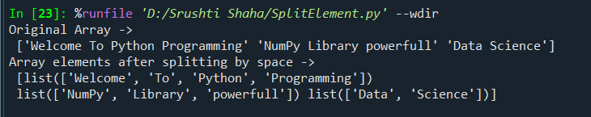

Practical Lab Experiment 3
3. Write a NumPy program to find the most frequent value in an array.

Code:
import numpy as np
arr = np.array([11,33,22,11,11,33,3,2,5,3])
values, count = np.unique(arr, return_counts=True)
most_frequent = values[np.argmax(count)]
print("Array : ",arr)
print("Most Frequent Values : ", most_frequent)

Output:

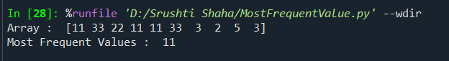

Practical Lab Experiment 4
4. Write a NumPy program to generate five random numbers from the normal Distribution.

Code:
import numpy as np
randomno = np.random.normal(0,1,5)
print("Five Random Numbers From Normal Distribution : ", randomno)

Output:

Practical Lab Experiment 5
5. Write a NumPy program to sort the specified number of elements from beginning of a array.

Code:
import numpy as np
arr = np.array([15,3,29,20,37,1,11,5])
print("Original Array : ", arr)
n = int(input("Enter the number of element to sort from beginning : "))
sorted_part = np.sort(arr[:n])
remaining_part = arr[:n]
result = np.concatenate((sorted_part, remaining_part))
print("Array after sorting first : ", n, "element", result)

Output:

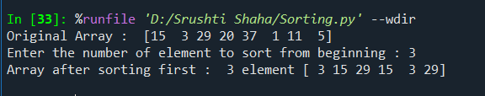

Practical Lab Experiment 6
6. Write a NumPy program to calculate the difference between the maximum and the minimum values of a array.

Code:
import numpy as np
# Sample array
arr = np.array([10, 20, 4, 45, 99])
# Difference between max and min
difference = np.max(arr) - np.min(arr)
print("Array:", arr)
print("\nMaximum Value:",np.max(arr))
print("\nMinimum Value:",np.min(arr))
print("Difference between max and min:", difference)

Output:

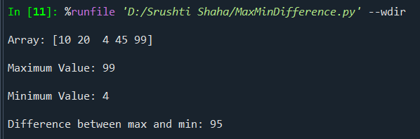

Practical Lab Experiment 7
7. Write a NumPy program to compute the cross product of two vectors.

Code:
import numpy as np
# Define two vectors
vector1 = np.array([1, 2, 3])
vector2 = np.array([4, 5, 6])
# Compute cross product
cross_product = np.cross(vector1, vector2)
print("Vector 1:", vector1)
print("Vector 2:", vector2)
print("Cross Product:", cross_product)

Output:

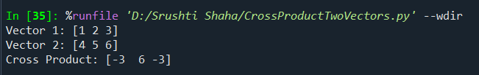

Practical Lab Experiment 8
8. Write a NumPy program to create a three dimension array.

Code:
import numpy as np
# Create a 3D array
arr = np.array([
[[1, 2, 3],
[4, 5, 6]],
[[7, 8, 9],
[10, 11, 12]]
])
print("3D Array:\n", arr)
print("\nShape of array:", arr.shape)
print("Number of dimensions:", arr.ndim)

Output:

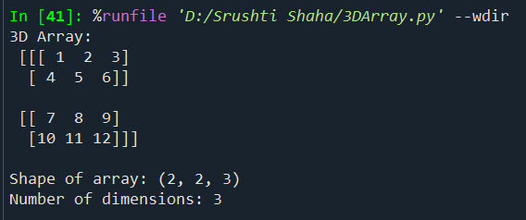

Practical Lab Experiment 9
9. Basics of Pandas.
1. Pandas Data Structures
2. Reading and Writing CSV Files
3. Reading and Writing Text
4. Reading Text Files in Pieces
5. Working with Delimited Formats
6. Binary Data Formats

Code:
import pandas as pd
# 1. Pandas Data Structures
print("1. Pandas Data Structures")
# Series
s = pd.Series([10, 20, 30, 40])
print("Series:\n", s)
# DataFrame
df = pd.DataFrame({
"Name": ["Srushti", "Shreya", "Vighnesh"],
"Age": [25, 30, 22]
})
print("DataFrame:\n", df)
# 2. Reading and Writing CSV Files
print("\n2. Reading and Writing CSV Files")
# Write CSV
df.to_csv("D:/Srushti Shaha/sample.csv", index=False)
# Read CSV
csv_df = pd.read_csv("D:/Srushti Shaha/sample.csv")
print("Read CSV:\n", csv_df)
# 3. Reading and Writing Text Files
print("\n3. Reading and Writing Text Files")
# Write text
with open("D:/Srushti Shaha/sample.txt", "w") as f:
f.write("Hello Pandas\nThis is a text file example.")
# Read text
with open("D:/Srushti Shaha/sample.txt", "r") as f:
text_data = f.read()
print("Read Text File:\n", text_data)
# 4. Reading Text Files in Pieces
print("\n4. Reading Text Files in Pieces (Chunking)")
# Reading CSV in chunks
for chunk in pd.read_csv("D:/Srushti Shaha/sample.csv", chunksize=1):
print("Chunk:\n", chunk)
# 5. Working with Delimited Formats
print("\n5. Working with Delimited Formats")
# Creating a TSV (Tab Separated Values) file
df.to_csv("D:/Srushti Shaha/sample.tsv", sep="\t", index=False)
# Reading TSV file
tsv_df = pd.read_csv("D:/Srushti Shaha/sample.tsv", sep="\t")
print("Read TSV:\n", tsv_df)
# 6. Binary Data Formats
print("\n6. Binary Data Formats (Pickle)")
# Save DataFrame in binary format
df.to_pickle("D:/Srushti Shaha/data.pkl")
# Load binary DataFrame
binary_df = pd.read_pickle("D:/Srushti Shaha/data.pkl")
print("Read Binary Pickle File:\n", binary_df)

Output:
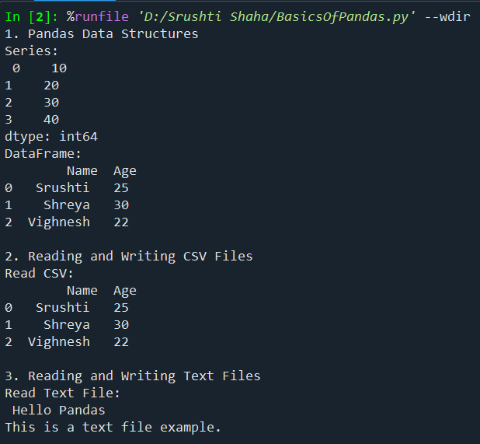
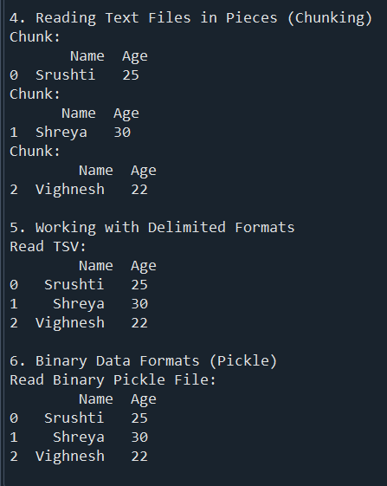
Practical Lab Experiment 10
10. Write a Pandas program to convert a NumPy array to a Pandas series.

Code:
import numpy as np
import pandas as pd
# NumPy array
arr = np.array([10, 20, 30, 40, 50])
# Convert NumPy array to Pandas Series
series = pd.Series(arr)
print("NumPy Array:", arr)
print("\nPandas Series:\n", series)

Output:

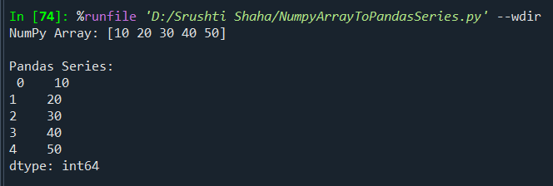

Practical Lab Experiment 11
11. Write a Pandas program to convert the first column of a DataFrame as a Series.

Code:
import pandas as pd
# DataFrame
data = {
'Name': ['Srushti', 'Shreya', 'Sanika', 'Snehal'],
'Age': [21, 25, 30, 28]
}
df = pd.DataFrame(data)
# Convert the first column to a Series
first_column_series = df.iloc[:, 0]
print("Original DataFrame:\n", df)
print("\nFirst Column as Series:\n", first_column_series)

Output:

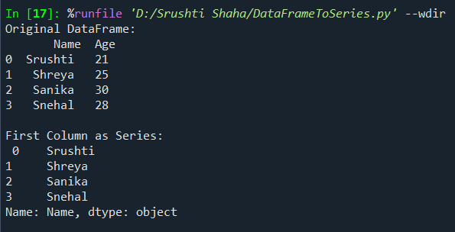

Practical Lab Experiment 12
12. Write a Pandas program to join the two given data frames along rows and assign all data.
Code:
import pandas as pd
df1 = pd.DataFrame({
'ID': [1, 2, 3, 4],
'Name': ['Srushti', 'Shreya', 'Sanika', 'Snehal'],
'Class': ['MCAII', 'MCAI', 'MBAII', 'MBAI']
})
df2 = pd.DataFrame({
'ID': [5, 6, 7],
'Name': ['Tulsi', 'Sakshi', 'Vaishnavi'],
'Class': ['MCAI', 'MCAII', 'MBAI']
})
result = pd.concat([df1, df2], ignore_index=True)
print("DataFrame 1:\n", df1)
print("\nDataFrame 2:\n", df2)
print("\nJoined DataFrame:\n", result)
Output:
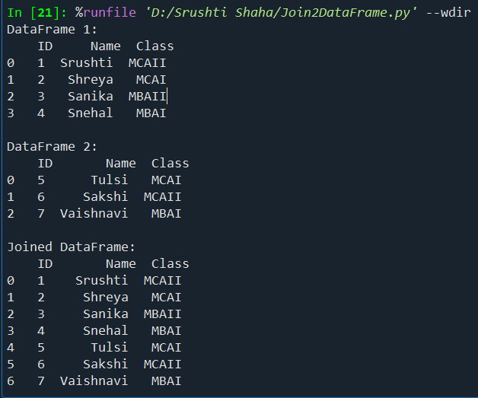
Practical Lab Experiment 13
13. Write a Pandas program to split the data frame.

Code:
import pandas as pd
emp=pd.DataFrame({
'ID':[11,12,13,14,15],
'Name':['Srushti','Shreya','Snehal','Sanika','Gauri'],
'Department':['HR','Sales','Marketing','Designer','HR']})
print("\nOriginal DataFrame:\n",emp)
df1=emp.iloc[:3]
df2=emp.iloc[3:]
print("\nSplit First 3 Rows:\n",df1)
print("\nSplit Remaining:\n",df2)

Output:
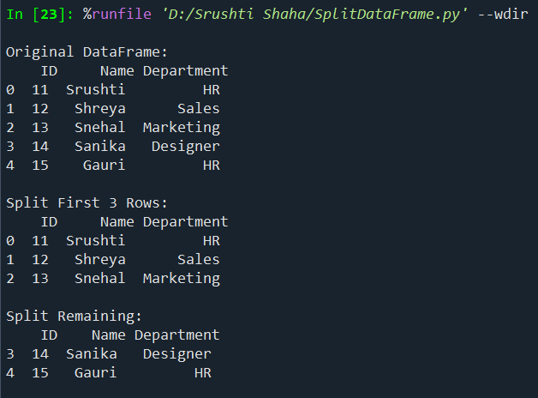
Practical Lab Experiment 14
14. Write a Pandas program to import excel data.

Code:
import pandas as pd
try:
excel_data = pd.read_excel("D:/Srushti Shaha/data.xlsx")
print("Excel File Data:")
print(excel_data)
except:
print("Excel file not found. Place 'sample.xlsx' in the same folder.")

Output:

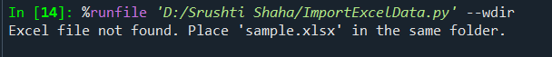

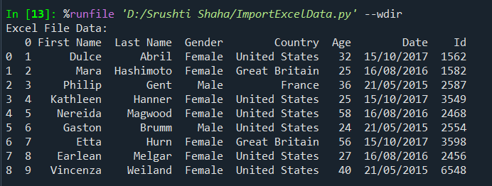

Practical Lab Experiment 15
15. Write a Pandas program to find and replace the missing values in a Data Frame.
Code:
import pandas as pd
import numpy as np
# A. Employee DataFrame
data = {
"Name": ["Srushti", "Shreya", " Vighnesh", "Sanika", "Snehal"],
"Age": [25, np.nan, 30, 28, np.nan],
"Salary": [30000, 45000, np.nan, 50000, 35000]
}
df_emp = pd.DataFrame(data)
print("\nEmployee DataFrame:\n", df_emp)
print("\nSummary Statistics:\n", df_emp.describe())
print("\nNull values:\n", df_emp.isnull().sum())
# Replace missing values (Correct way)
df_emp["Age"] = df_emp["Age"].fillna(df_emp["Age"].mean())
df_emp["Salary"] = df_emp["Salary"].fillna(df_emp["Salary"].median())
print("\nAfter replacing missing values:\n", df_emp)
# B. Products.csv
df_prod = pd.read_csv("D:/Srushti Shaha/products.csv")
print("\nProducts Summary:\n", df_prod.describe())
print("\nNull values:\n", df_prod.isnull().sum())
# Replace missing price
df_prod["Price"] = df_prod["Price"].fillna(df_prod["Price"].mean())
print("\nAfter replacing missing values:\n", df_prod)

Output:

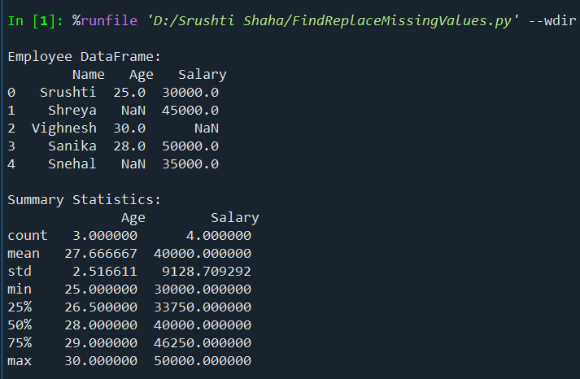
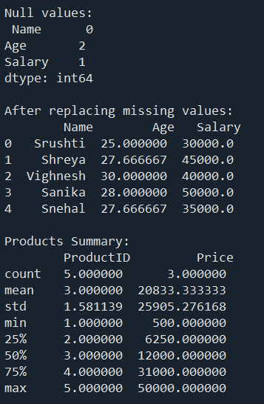
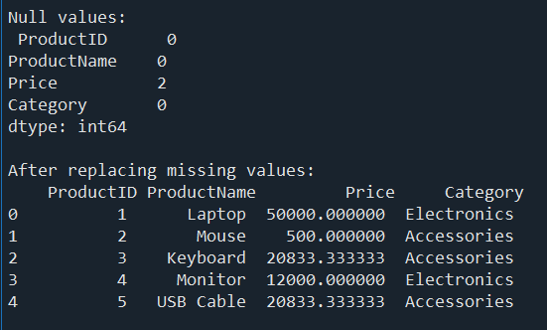

Practical Lab Experiment 16
16. Write a Pandas program to split the datasets into groups.
Code:
import pandas as pd
data = {
'Department': ['IT', 'IT', 'HR', 'HR', 'Finance'],
'Employee': ['A', 'B', 'C', 'D', 'E'],
'Salary': [50000, 60000, 45000, 48000, 70000]
}
df = pd.DataFrame(data)
grouped = df.groupby('Department')
print(grouped['Salary'].mean())
for dept, group in grouped:
print(f"\nDepartment: {dept}")
print(group)

Output:
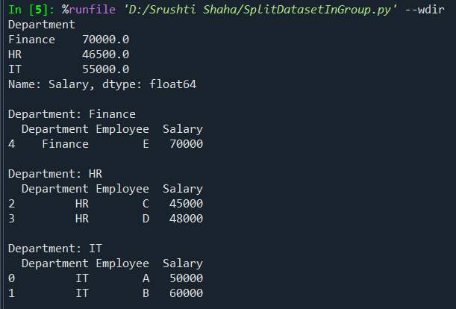
Practical Lab Experiment 17
17. Write a Pandas program to create a line plot.
Code:
import pandas as pd
import matplotlib.pyplot as plt
# Data
data = {
'Month': ['Jan', 'Feb', 'Mar', 'Apr', 'May', 'Jun'],
'Bags': [2000, 2500, 3000, 2800, 3500, 4000],
'Notebooks': [2200,2500,1500,3000,2250,4000]
}
df = pd.DataFrame(data)
print(df)
# Create Line Plot
plt.plot(df['Month'], df['Bags'])
plt.plot(df['Month'], df['Notebooks'])
plt.xlabel("Month")
plt.ylabel("Sales")
plt.title("Monthly Sales Line Plot")
plt.show()

Output:

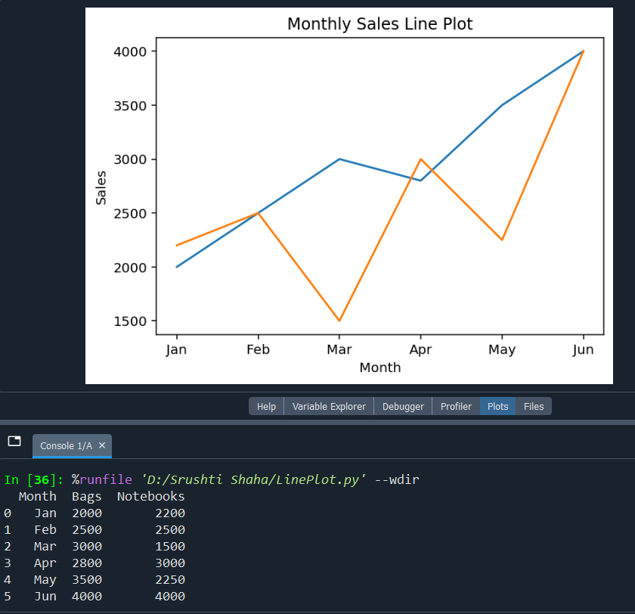

Practical Lab Experiment 18
18. Demonstration on Chart.
1.Create a Data Frame for student Mark sheet
2. Plot Bar Chart
3. Plot Pie Chart
4. Plot Histogram
5. Plot Scatter

Code:
import pandas as pd
import matplotlib.pyplot as plt
# 1. Create DataFrame for Student Marksheet
data = {
'Student': ['Srushti', 'Shreya', 'Snehal', 'Sanika', 'Mayuri'],
'Age': [23, 29, 32, 38, 50],
'Data Analytics': [98, 78, 92, 74, 88],
'Java': [90, 82, 89, 76, 85],
'Cyber Security': [88, 79, 94, 72, 80],
'Cloud': [90, 82, 89, 76, 85]
}
df = pd.DataFrame(data)
print(df)
# 2. Bar Chart (Data Analytics Marks)
plt.figure(figsize=(7,4))
plt.bar(df['Student'], df['Data Analytics'])
plt.title("Data Analytics Marks - Bar Chart")
plt.xlabel("Student")
plt.ylabel("Marks")
plt.show()
# 3. Pie Chart (Java Marks)
plt.figure(figsize=(6,6))
plt.pie(df['Java'], labels=df['Student'], autopct='%1.1f%%')
plt.title("Java Marks - Pie Chart")
plt.show()
# 4. Histogram (Age)
plt.figure(figsize=(7,4))
df['Age'].plot(kind='hist',bins=5,color='lightgreen',edgecolor='black')
plt.title("Age - Histogram")
plt.xlabel("Age")
plt.ylabel("Frequency")
plt.show()
# 5. Scatter Plot (Data Analytics vs Cloud)
plt.figure(figsize=(7,4))
plt.scatter(df['Data Analytics'], df['Cloud'])
plt.title("Data Analytics vs Cloud - Scatter Plot")
plt.xlabel("Data Analytics")
plt.ylabel("Cloud")
plt.show()

Output:

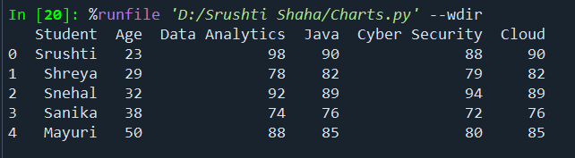

- Bar Chart:

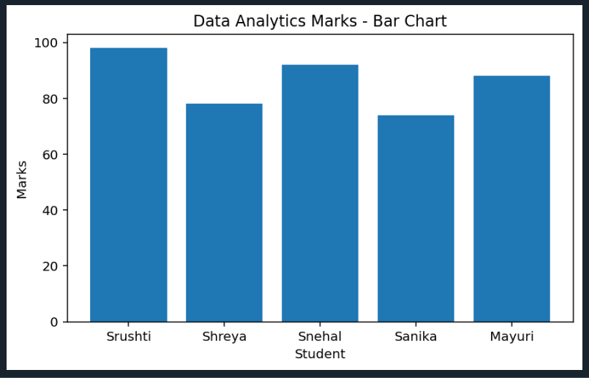

- Pie Chart

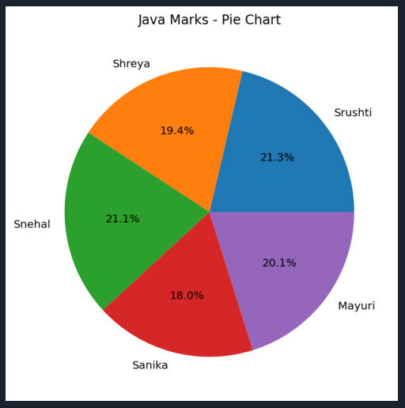

- Histogram

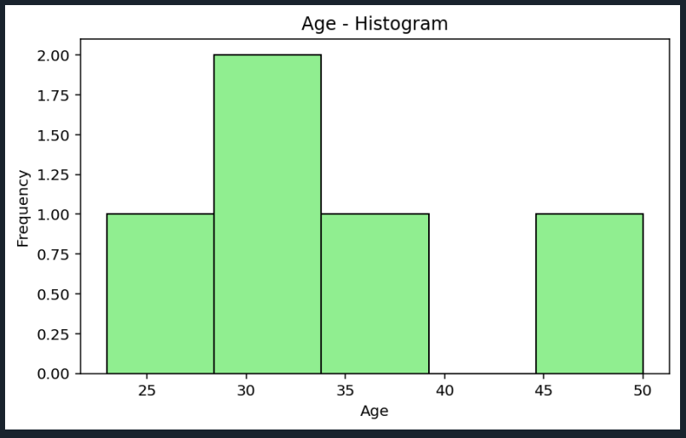

- Scatter

